**UNIVERSITY OF DAR ES SALAAM**



**COLLAGE OF INFORMATION AND COMMUNICATION**

**TECHNOLOGIES**

**DEPARTMENT OF COMPUTER SCIENCE AND ENGINEERING**

**IS 171 LAB WORK**

**__________________________________________________________________________**

**Lab Work No.:** 02 **Date Conducted:** April 20, 2022

**Title**: MAKING CONNECTIONS NETWORKING DEVICES/NODES USING CAT5c CABLE

**Group**: CS 04

**Group** **Members**:

|  |  |  |
| --- | --- | --- |
| **Sn.** | **Name** | **Reg. No** |
| 1. | Shine, Philipina Felichism | 2021-04-11635 |
| 2. | Kimario, Lauryn Method | 2021-04-04103 |
| 3. | Mariki, Whitney Gerald | 2021-04-05873 |
| 4. | Lwiza, Ashley Egbert | 2021-04-05069 |
| 5. | Karashani, Nancy Nickson | 2021-04-03520 |
| 6. | Gulay, Edgar Edward | 2021-04-02100 |
| 7. | Liana, Hassan Jafary | 2021-04-04774 |
| 8 | Kanga, James Fidelis | 2021-04-03437 |
| 9 | Said, Shabani Nassibu | 2021-04-10934 |

**Submission Date:** May 11, 2022

**Marks:…………………………………..Approved:……………………… Date:…………………...**

**Remarks:………………………………………………………………………………………………..**

1. **Introduction**

**Theory**:

Ethernet cable is a network cable used for high-speed wired network connections between two devices. This network cable is made of four-pair cable, which consists of twisted pair conductors. It is used for data transmission at both ends of the cable, which is called the RJ45 connector.

There are two ways on how Ethernet cables are wired; straight-through and crossover depending on which pin on one end is connected to which pin on the other end.

**Straight-through cable**  is a type of CAT5 with RJ45 connectors at each end, and each has the same pin out(how an electrical cable is wired). It is used to connect a computer to a network hub such as a router. It's arranged in accordance with either the **T568A** or **T568B** standards.

Although T568B Ethernet pin out is the most widely used, the T568A wiring scheme is seen as the better wiring scheme for RJ45 modular plugs because it provides reverse compatibility to not only one but also two pair USOC wiring set ups.

1. **Objectives**

Objective of this experiment was to create/make connections between two different

Networking Nodes (Computer & Hub) by using Twisted Pair cable (Cat5e cable).

1. **Apparatus/Equipment list**
   * + - EZ RJ45 CONNECTORS
         * 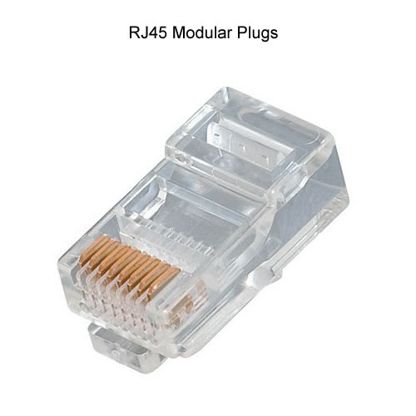the RJ in RJ45 is an abbreviation for registered jack, as it is standardized networking interface. The number 45 only refers to the number of the interface standard. All RJ45 connectors have eight pins, which means an RJ45 cable includes eight separate wires. If you look closely at the termination of an ethernet wire, you could even see the eight wires, that are each a distinguished color.  Half of them are striped, while the rest are solid colors.
         * An RJ45 cable is fundamentally utilized to connect devices over an Ethernet connection. Devices like computers, printers, network storage devices, and cable or DSL modems are able to use an RJ45 connection.

* MODULAR CRIMPING/CABLE CUTTING TOOL
  + Enables cable cutting, stripping and crimping with a single tool.  
    With a ratchet mechanism, this tool ensures simple and secure crimping work.

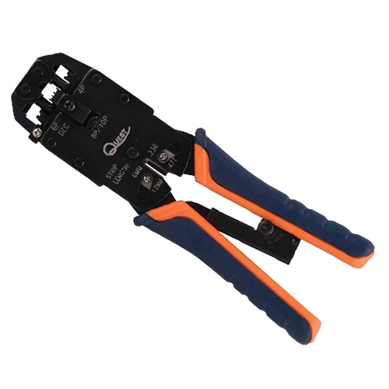 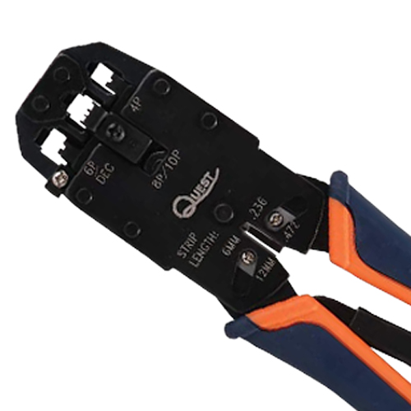

* UTP CABLE STRIPPING TOOL
  + This multi-purpose economy cable stripper is a versatile product for cable preparation. A strip length gauge allows the removal of a wide variety of jacket materials for UTP and STP cables. It is manufactured with high-quality materials with long life cutting blades to provide stripping consistency.

* UTP ETHERNET CABLE
  + 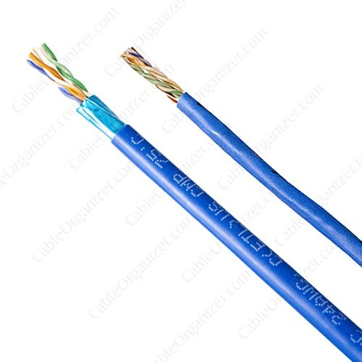UTP cables are mostly used for LAN networks. They can be used for voice, low-speed data, high-speed data, audio and paging systems, and building automation and control systems. UTP cable can be used in both the horizontal and backbone cabling subsystems.

`

1. **Experiment Procedures**

* The sheath of Cat5e cable was stripped (approximately a distance of 1.5inches) at each end.
* Wires were untwisted on both ends.

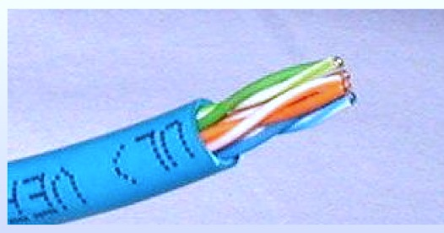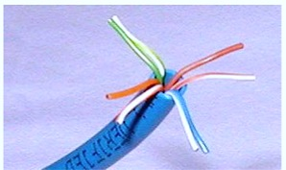

* Wires were arranged by

following the color order of T568A. From left-to-right; White/Green, Green, White/Orange, Blue, White/Blue, Orange,White/Brown, Brown. The step was done to both ends, meaning that Straight-Through method was applied.

* Wires were trimmed evenly (2.5cm), leaving about 0.5 inches of wires exposed.

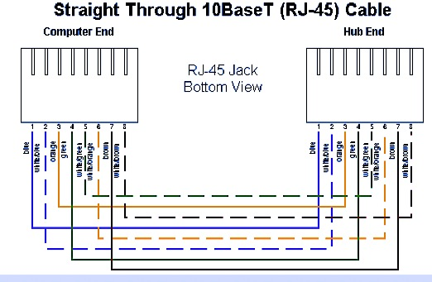

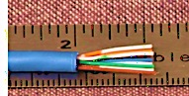

* RJ-45 Connectors were attached, on both ends, by making sure that wire order is maintained from left-to-right with the RJ-45 Tab facing downward.
* Check up was done to ensure that all wires extended to the end, and the sheath was well placed inside the RJ-45 Connector.
* Crimping tool was used to crimp connector to the cable end. It was done on both sides.

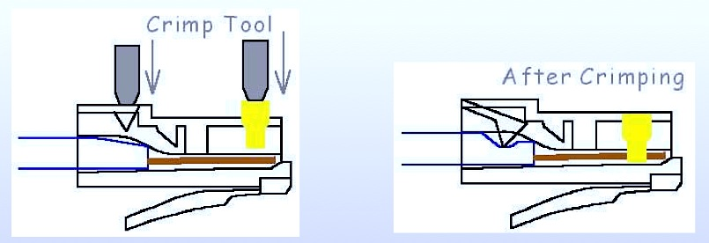

* Each end was connected to the special tool (Multi-Network Modular Cable Tester) to test their connectivity, and the Green Signals displayed properly indicating that the connection was successfully.

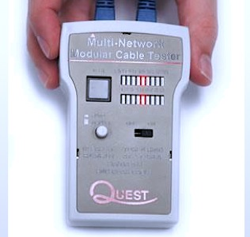

1. **Results**

Green light signals were displayed on the Tester indicating that connection between

each end was successfully.

The green lights from the tester blinked simultaneously from all endpoints of the connection.

1. **Conclusion**

Green signals being displayed on the Tool doesn’t totally prove that the Transmission

factors (attenuation, interference, etc.) are well controlled. On the other hand, it’s

likely for the Red signals to be displayed on the Tool indicating that a certain number

of pins are wrongly arranged. When making a connection between networking

nodes/devices using a Twisted pair cable, you must consider the type of networking

devices. Straight-Through (either T568A on both ends or T568B on both ends) is used

to the same type of networking devices. Cross-over (T568A on one end, T568B on the

other end) is used to different type of networking devices.

1. **References**

* [www.cableorganizer.com/learning-center/how-to/how-to-terminate-rj45.htm](http://www.cableorganizer.com/learning-center/how-to/how-to-terminate-rj45.htm)
* <https://www.guru99.com/difference-between-straight-through-crossover-cables.html>
* Router-switch Ltd(2002-2022).Hong Kong Yejian Technologies Co., Ltd <https://www.router-switch.com/faq/difference-between-straight-through-and-crossover-cable.html>
* Kurose, James F. & Ross, Keith W. (2013). Computer Networking: A Top-Down Approach (6th Edition). United States of America: Pearson Education Inc.
* Tanenbaum, Andrew S. & Wetherall, David J. (2011). Computer Networks (5th

Edition). United Sates of America: Pearson Education Inc.